User Guide:
Salesforce Right to Rent

Version History
Version | Description of Change | Author | Date
0.1 | First Version | Nikki Papenfus | 13/01/2025
2.0 | ‘RTR not Required’ flag added to person account. Updated validation logic. ‘RTR Outstanding’ & ‘RTR Status’ flags displayed for Tenancy Reviews. | Nikki Papenfus | 07/08/2025

Table of Contents
1. Overview 3
1.1 Follow Up Process 3
1.2 Reminder & Follow Up Timelines 4
2. Right to Rent Information 4
2.1 Where to Find RTR Information 8
2.2 Person Account 8
3. Check RTR at New Let, Change or Sharer or Tenancy Review 9
3.1 Checking RTR for a New Lease or Mid-Term Change 9
3.2 Checking RTR for a Tenancy Review 10
3.3 Completing an Opportunity 11
4. Automated Email Reminders 12
4.1 Tenant Replies 13
4.2 Bounced Emails 13
5. Manual Follow Up 13

Overview
Grainger is required to check that all tenants in England aged 18 and over have a legal right to rent a residential property.
Where a tenant’s right to rent is for a limited time period and will expire during their tenancy, Grainger must also conduct follow-up checks when the right to rent expires or after 12 months, whichever is later. If a follow-up check shows that a person no longer has the right to rent, an official report must be made to the Home Office.
While tenants in Wales, in social housing or in accommodation provided by a local authority are not required to provide a right to rent, it is Grainger policy to request this documentation. However, failure to provide it should not impede a new let or renewal for these tenants.
This user guide details the process to:
- Capture a record of right to rent checks (as well as reports to the home office).
- Check that the necessary right to rents have been obtained at new let or renewal.
- Follow-up with an existing tenant for a new right to rent when theirs is due to expire.

Follow Up Process
The process to follow up with an existing tenant for a new right to rent will take place initially via a series of automated reminder emails and, if the tenant has still not provided the necessary information, thereafter via manual follow-up by the Onsite Property Management Team.
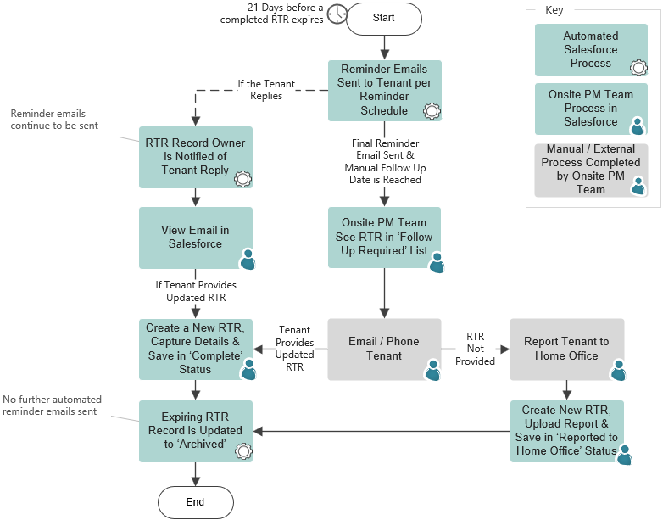

Reminder & Follow Up Timelines
Automated email reminders will be sent according to the following timelines:
If RTR Expires before Check Date Anniversary:
21 days before Expiry Date | Reminder Email 1
14 days before Expiry Date | Reminder Email 2
10 days before Expiry Date | Reminder Email 3
60 days before Check Date Anniversary | Reminder Email 4
42 days before Check Date Anniversary | Reminder Email 5
30 days before Check Date Anniversary | Final Reminder Email
28 days before Check Date Anniversary | Start Manual Follow Up
If RTR Expires after Check Date Anniversary:
21 days before Expiry Date | Reminder Email 1
14 days before Expiry Date | Reminder Email 2
10 days before Expiry Date | Final Reminder Email
7 days before Expiry Date | Start Manual Follow Up

Right to Rent Information
Right to rent checks and documents, as well as reports to the Home Office, are captured on the Right to Rent (RTR) object in Salesforce.
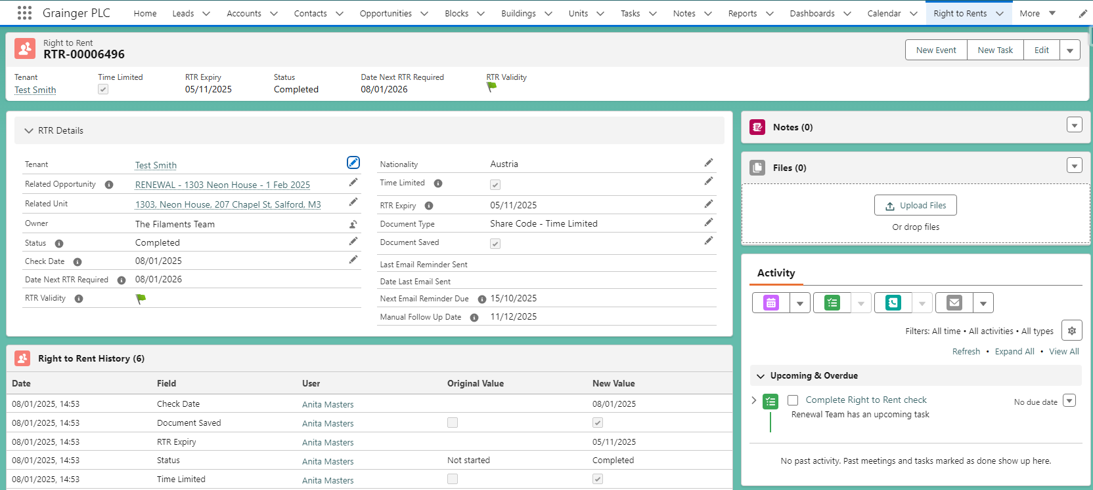
View a history of all updates to key fields.
Associated tasks & emails will display in the activity timeline.
Upload any documents provided or Home Office report.
The RTR record will progress through a sequence of statuses:
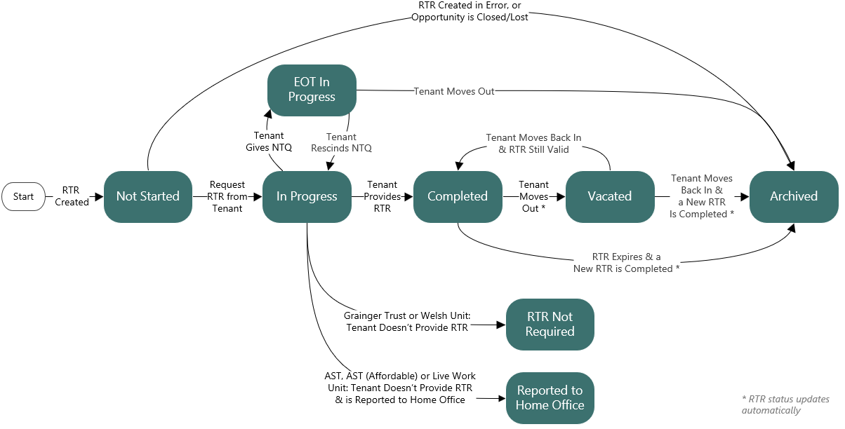

The RTR status must be kept up-to-date, and will update automatically in the following circumstances:

- When a new RTR record for an existing tenant is completed, the previous RTR for that tenant will be automatically updated to an Archived status.
  - I.e. When a RTR is saved with one of the following statuses: Completed, RTR Not Required, Vacated or Reported to Home Office, then any other RTR for the same tenant that is Completed, RTR Not Required or Vacated will update to ‘Archived’.
- Once a month, IT will update any ‘Completed’ RTR records to a Vacated status if the tenant has moved out.

The follow details may be captured on the RTR:

Right to Rent Information to be Captured
Tenant
Related Opportunity | The opportunity associated with the tenant originally moving in.
Related Unit | This does not need to be manually selected; it will automatically update on saving, based on the Related Opportunity.
Owner | This does not need to be manually selected; it will automatically update on saving to the relevant Onsite Property Management Team, based on the Related Opportunity.  If there is no Onsite PM Team configured in Salesforce, the owner will default to the Renewals Team.
Status | Select the applicable status, as above.
Check Date | Date on which the RTR checks were completed.  This cannot be more than 28 days before the tenant moves in.  This will be validated against the move-in date for the Related Opportunity.
Nationality
Time Limited
RTR Expiry | Only applicable where RTR is time-limited
Document Type
Additional Document Type | Some Document Types should be corroborated with a second document.
Document Saved | Tick this to confirm that the document(s) have been saved on the RTR.  Documents are required where the RTR status is Completed or Reported to Home Office.

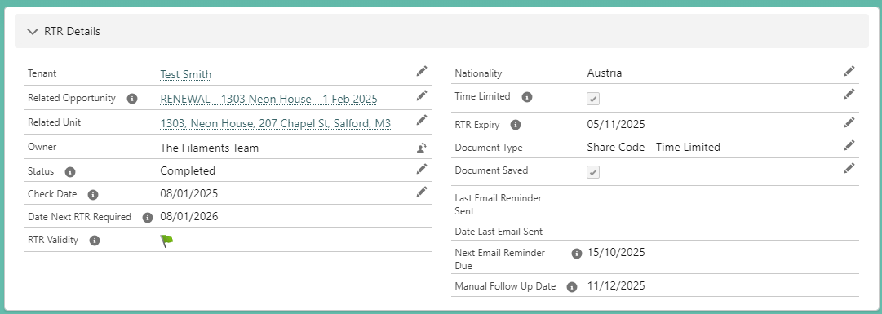

Where sufficient information has been captured, the RTR Validity will be indicated:

- - Where RTR Not Required, is not time limited, or is still valid for more than 60 days.
- - The next RTR is due within the next 60 days.
- - The next RTR is overdue, or the tenant has been reported to the Home Office.

The follow information will also display where a RTR is time-limited:

- Date Next RTR Required - This is the later of:
  - The RTR expiry date, or
  - The anniversary of the check date (i.e. 1 year after the check date).
- Last Email Reminder Sent – Most recent automated email sent to the tenant.
- Date Last Email Sent – Date on which the most recent automated email was sent.
- Next Email Reminder Due – The date on which the next automated email will be sent, according to the reminder & follow up timelines.
  - If the date falls in the past, then the email will send tomorrow.
- Manual Follow Up Date – The date on which the Onsite Property Management team should start manual follow up if no response has been received from the tenant.

Where to Find RTR Information
RTR information in Salesforce can be accessed in from:
- Person Account – See a summary of RTR information for an individual tenant
- Opportunity – Users can check RTR at new let, change of sharer, or tenancy review on the opportunity which will display the most recent RTR information for each associated tenant.
- Right to Rents menu option – Access various list views:

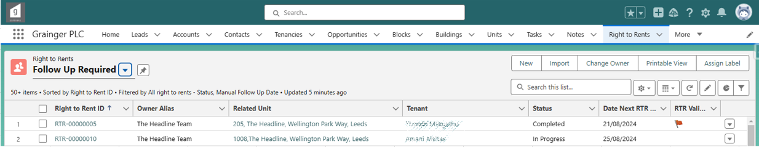

Person Account
A summary of right to rent information for a tenant can be viewed on the person account.
- When a RTR is completed, marked ‘RTR not Required’, or the tenant is reported to the Home Office, the person account will automatically reflect the latest RTR information:
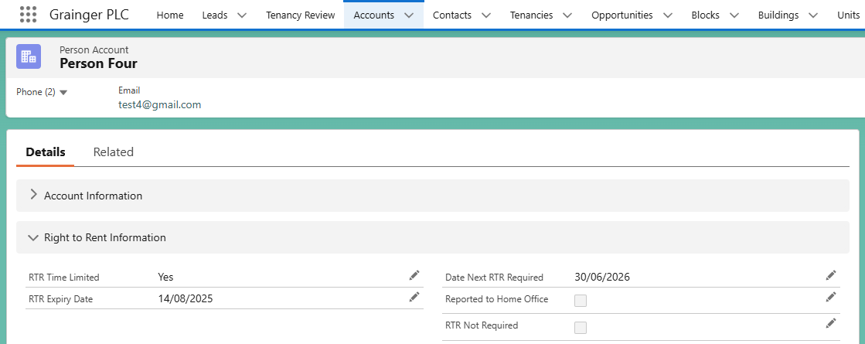
- A list of all RTR records for the tenant can be seen on the Related tab:
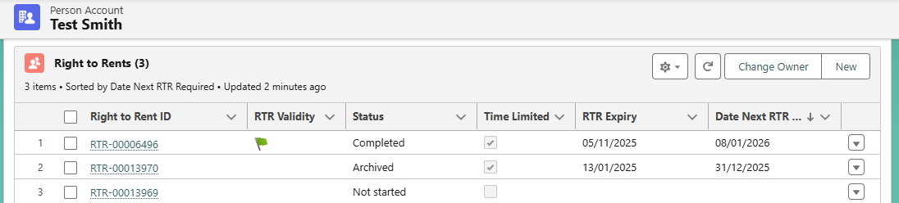
Creates a new, blank RTR for the tenant

Check RTR at New Let, Change or Sharer or Tenancy Review

Checking RTR for a New Lease or Mid-Term Change
When reviewing an opportunity for a new lease, tenancy review or mid-term change, check the Right to Rents summary on the Related tab to see the latest RTR information for all tenants.
- RTR information is not displayed for permitted occupiers or other roles as it is only necessary to check the right to rent for tenants. It is therefore important to ensure that the correct contact roles have been selected.
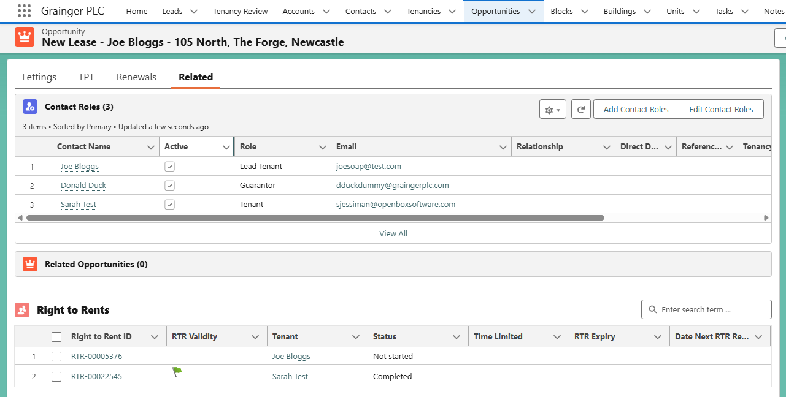
Displays all existing RTR records for Lead Tenants & Tenants where the RTR is not in an Archived status.

- Note that when a new opportunity is created, or when a tenant / lead tenant is added to an opportunity, the system will automatically create a new RTR & linked task for the tenant if:
  - The tenant does not have any RTR records, or
  - All of their RTR records have been Archived, or
  - Their latest Completed or Vacated RTR is time-limited and a new RTR is required before the start / move-in date of the opportunity.

Checking RTR for a Tenancy Review
When reviewing a tenancy review opportunity, RTR information can be checked in a number of places:
- RTR Outstanding – This can be viewed on the Reviews in Progress list, as well as on the opportunity, and summarises the overall RTR status for the opportunity:
  -  - A new RTR is required from one or more tenants.
  - - One or more tenants have a RTR in ‘RTR Not Required’ status.
  - - All tenants have a RTR that is valid as at the opportunity’s start date (i.e. the date of the rent increase).
  - This flag only displays for Agreement Types that require RTR information to be captured.

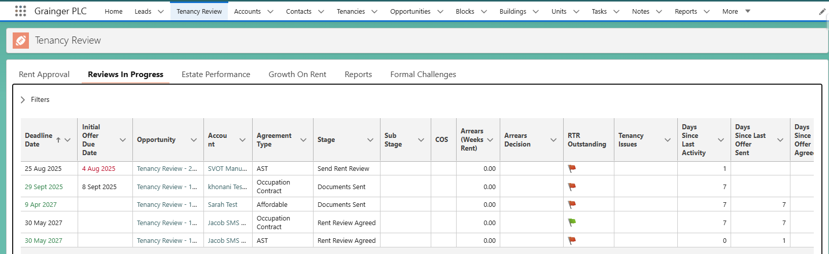
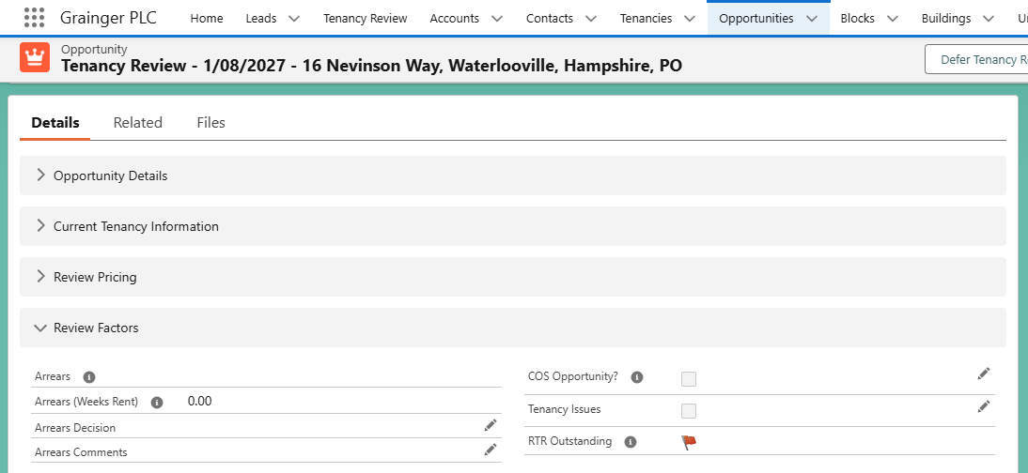

- RTRs are required.
- Tenant(s) are flagged as ‘RTR Not Required’

- Contact Roles – The RTR Status displays for each individual tenant and lead tenant. The RTR status is relative to the opportunity’s start date (i.e. the date of the rent increase).
- Right to Rents summary on the Related tab - Displays the latest RTR records for all tenants.
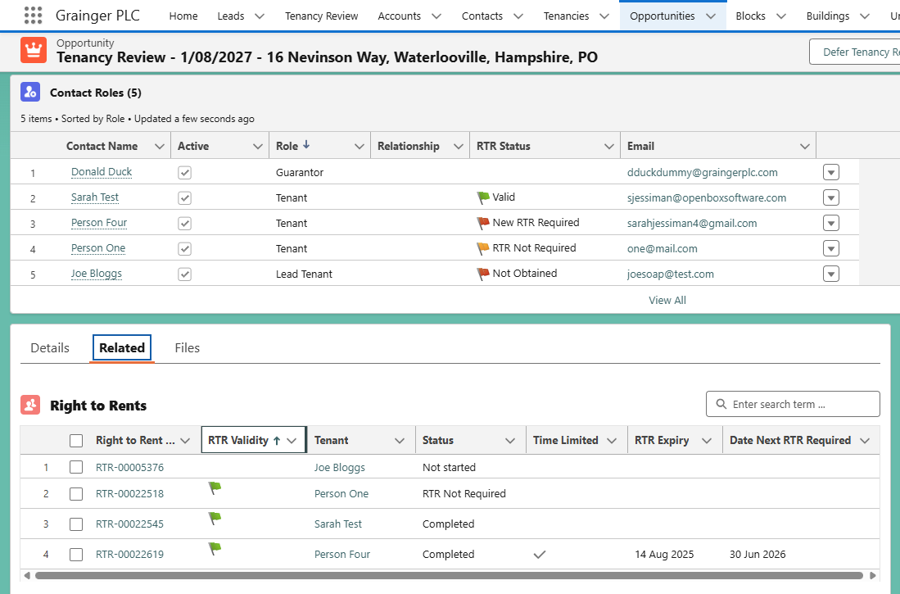
RTR status for each Lead Tenant & Tenant relative to the date of rent increase.

Displays all existing RTR records for Lead Tenants & Tenants where the RTR is not in an Archived status.

Completing an Opportunity

A residential opportunity will be prevented from moving to the Audit stage until all tenants have a valid RTR.
- This check will be applied to all opportunity’s for AST, AST (Affordable), Assured, DMR, DMR Social or Live Work agreement types.
- Each tenant must have a RTR that is either:
  - Not time-limited and in a ‘Completed’ status, or
  - Time-limited, in a ‘Completed’ status and the Date Next RTR Required is after the opportunity’s Start Date, or
  - For tenants in Wales & Grainger Trust units only: In a 'RTR Not Required' status.

Automated Email Reminders
Where a time-limited RTR is approaching its expiry date, Salesforce will automatically send the tenant a series of reminder emails according to the below schedule. Reminder emails are sent each morning.
Reminder emails will only be sent where the RTR is in a ‘Completed’ status.

If RTR Expires before Check Date Anniversary
21 days before Expiry Date | Reminder Email 1
14 days before Expiry Date | Reminder Email 2
10 days before Expiry Date | Reminder Email 3
60 days before Check Date Anniversary | Reminder Email 4
42 days before Check Date Anniversary | Reminder Email 5
30 days before Check Date Anniversary | Final Reminder Email
28 days before Check Date Anniversary | Start Manual Follow Up
If RTR Expires after Check Date Anniversary
21 days before Expiry Date | Reminder Email 1
14 days before Expiry Date | Reminder Email 2
10 days before Expiry Date | Final Reminder Email
7 days before Expiry Date | Start Manual Follow Up

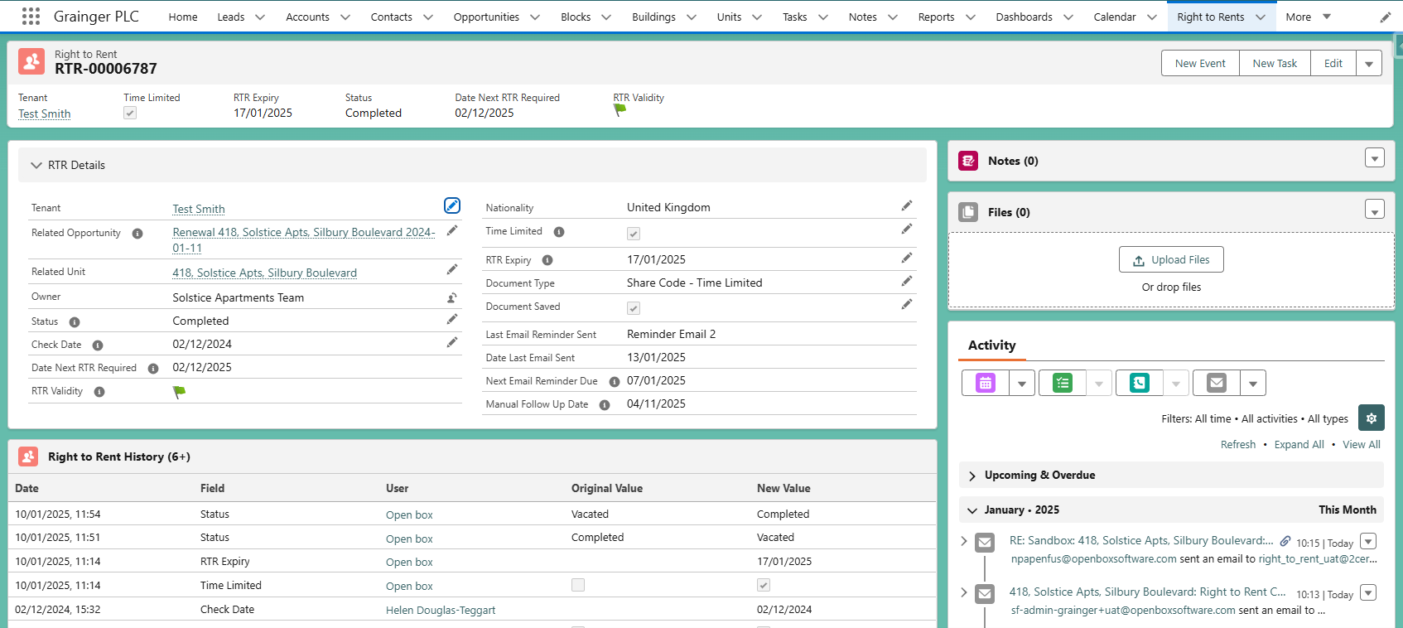
Next Email Reminder Due date & Manual Follow Up Date are calculated according to the above timelines.
Automated reminder emails sent & any direct replies will display here. Click on the email subject line to see attachments.

Tenant Replies
If a tenant replies to an automated reminder email:
- The RTR record owner will receive an email notification of the reply.
  - The email can be sent to a shared mailbox for the relevant team, otherwise
  - Each member of the team will receive an notification email.
- The reply can be viewed in the RTR activity timeline (as above).

Bounced Emails
If an automated reminder email bounces:
- The RTR record owner will receive an email notification.
- Automated reminder emails will no longer be sent to the tenant.
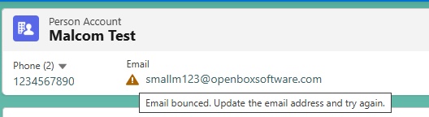
If the tenant’s email is subsequently updated, the automated reminder email sending will resume.

Not all invalid email addresses will result in a bounced email notification.
It is important to ensure all tenant’s emails on Salesforce are correct and up-to-date.

Manual Follow Up
A list of RTRs that need to be worked on can be accessed under the Right to Rents menu option, in the Follow Up Required list.
This list displays:
- All incomplete RTR records (i.e. in status Not Started, In Progress or EOT in Progress).
- All completed RTRs that are expiring soon and require manual follow up (see Reminder & Follow Up Timelines).
